**TIC TAC TOE**

**About the game:**

The project is built with a WPF application. The game uses a 3x3 grid that allow the player to play tic-tac-toe with the AI. The user or the player that marks in a horizontal, vertical, and diagonal wins the game. I use a menu navigation that includes a file the help the user understands the game. In the menu navigation list there are options for the user to select a new game, player vs player, and exiting out the game. In the help tab you also have about tab, describing who did the project, and also there is an information tab describing how to play the game.

**Raptor Explanation**

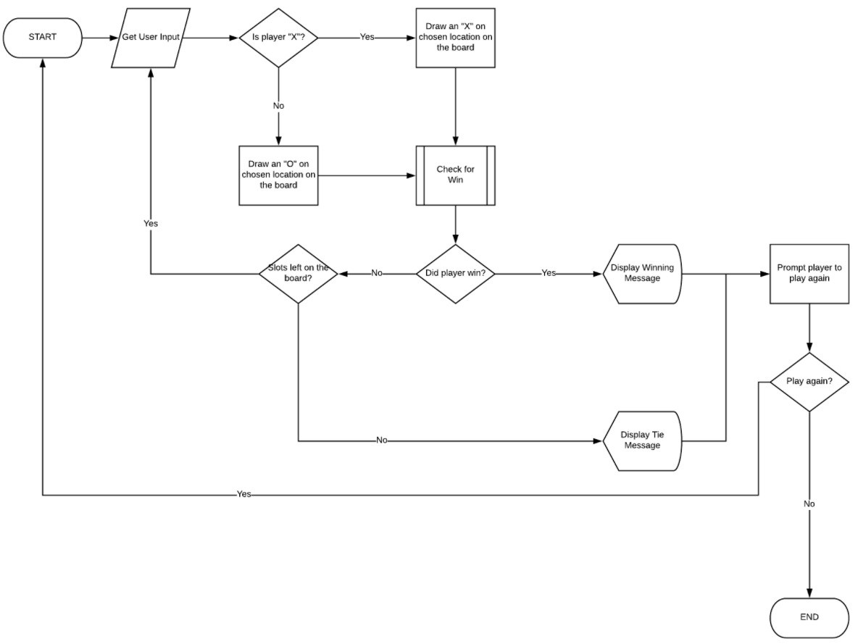

**Interface Design :**

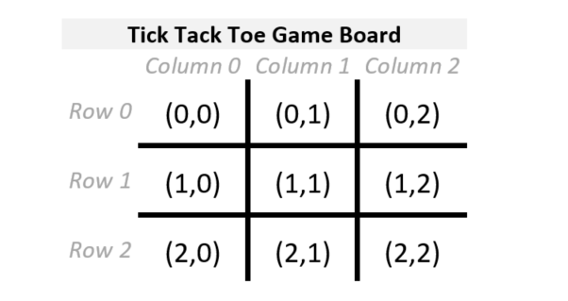

**This is my java Script source code:**

if (tile == null) {

(function() {

var _c = document.createElement("canvas");

_c.width = _c.height = 100;

var _ctx = _c.getContext("2d");

_ctx.fillStyle = "orange";

_ctx.lineWidth = 4;

_ctx.strokeStyle = "white";

_ctx.lineCap = "round";

// Blank

_ctx.fillRect(0, 0, 100, 100);

Tile.BLANK = new Image();

Tile.BLANK.src = _c.toDataURL();

// Nought

_ctx.fillRect(0, 0, 100, 100);

_ctx.beginPath();

_ctx.arc(50, 50, 30, 0, 2*Math.PI);

_ctx.stroke();

Tile.NOUGHT = new Image();

Tile.NOUGHT.src = _c.toDataURL();

// Cross

_ctx.fillRect(0, 0, 100, 100);

_ctx.beginPath();

_ctx.moveTo(20, 20);

_ctx.lineTo(80, 80);

_ctx.moveTo(80, 20);

_ctx.lineTo(20, 80);

_ctx.stroke();

Tile.CROSS = new Image();

Tile.CROSS.src = _c.toDataURL();

})();

tile = Tile.BLANK;

}

**Java Script Explanation:**

This are the design in java script giving each square its design.

The width, height, color, and the inside shape. The Tile.NOUGHT.src= c.toDataURL(); and Tile.Cross.src =c.toDtaYRL(); it makes the object show in the browser.